**5. GIT_HOL**

**Objectives**

* Explain how to clean up and push back to remote Git.

**In this hands-on lab, you will learn to**

* Execute steps involving clean up and push back to remote Git.

**Estimated time: 10 minutes**

**Steps to Perform**

1. **Verify if master is in a clean state**

git checkout master

git status

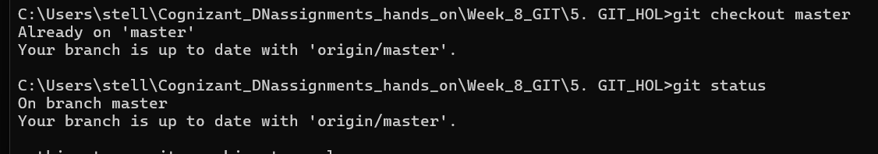

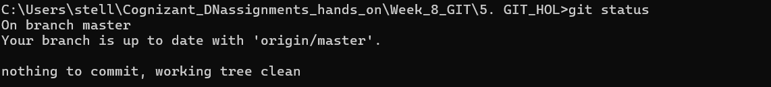

If you see "nothing to commit, working tree clean," you’re good to proceed.

**2️⃣ List all available branches**

git branch -a



The -a option shows both local and remote branches.

**3️⃣ Pull the latest changes from the remote repository**

git pull origin master



This ensures your master is up to date with the remote before pushing.

**4️⃣ Push pending changes from Git-T03-HOL_002**

If you made changes in a branch during **Git-T03-HOL_002**, switch to that branch and push it:

git checkout Git-T03-HOL_002

git push origin Git-T03-HOL_002

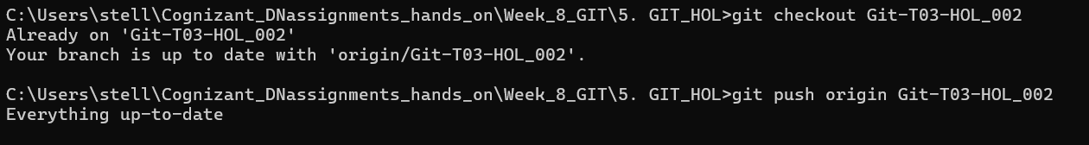

If changes were already merged into master, simply:

git push origin master



**5️⃣ Verify changes in the remote repository**

* Go to your GitHub (or GitLab) repository in the browser.
* Check if the pushed commits are visible in the branch or master.
* Confirm file changes are updated.